**FIELD TERMINATION PLUG - CAT.8.1/CLASS I**

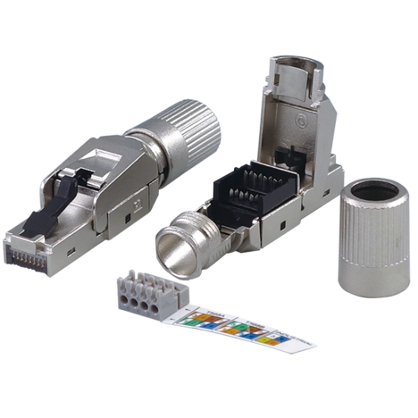

IKCOM plug is made of fully sturdy metal housing. The plug is designed to be simple and easy to be terminated with the twisted cables at field. The IDC is designed to accommodate different diameter conductors up to 22AWG. All eight conductors are terminated at same time when the wire cap is squeezed by plier. This process ensures consistent, reliable termination.

The plug is ideal product for HD Base-T® installation and Direct Connect Networks. The simple termination design enable the installers easy to achieve Cat.8.1/Class I performance requirement while construct of high-performance custom-length cable assemblies in field/data center

**Features**

Fully zinc alloy metal housing

Wiring label: TIA 568A/B & PNO

Protection category: IP20

Durability: 750 mechanical cycles

Termination capability: 22-26 AWG solid wire / 22-27 AWG stranded wire

Supporting cable diameter: 5.5-9mm

Force EC Class I verified

4PPoE compliant in accordance with IEEE802.bt Type 4

**Ordering Information**

|  |  |
| --- | --- |
| **Part No.** | **Description** |
| **IKC-FTPS811** | CAT.8.1/Class I STP Field termination plug |